R19/R21 FPGA Testbench
Design description

CONTENTS
1. INTRODUCTION 3
1.1 Related Documents 3
1.2 Definitions 3
2. Design description 3
2.1 Overview 3
2.2 Ecs top tb mem 4
2.3 Filehandler 5
2.4 M25P80 5
2.5 Eeprom 5
2.6 Feedback tester 5
2.7 ADC sim 6
2.8 Gate drive tester 6
2.9 PWM tester 6
2.10 Etherca uc16 wrapper 6
2.11 PDI sim 7
2.12 Ethercat slave sim 7
2.13 tbDefinitions 8
3. Testcases 8
4. Stimuli files 22
4.1 Process stimuli file 22
4.2 Text file generator 22
4.3 ADC stimuli file 26
5. Running the testbench 26
SUMMARY
This document describes the functions of the R19/R21 VHDL testbench. It is described how it is implemented, which testcases that can be run and what the testcases does. The testbench for R19(6 axis) and R21(1 axle) design is the same except that functionality is removed in R21 since there is only one axle and no rectifier control in the R21 design.

INTRODUCTION
The testbench purpose is to simulate the R19 and R21 FPGA designs. Stimuli are generated to the design and the output from the design is checked automatically. This document only describes the top test bench used for complete design simulation. Some of the blocks in the design have separate test benches to test there functions more deeply. They are described in the implementation specifications for the specific blocks.

Related Documents
Ref | Doc. ID | Title
[1] | 3HAB5698-1 | FPGA R19 Functional specification

Definitions

Word | Description
VHDL | Very High speed integrated circuit Hardware Description Language
ECM | Ehtercat master
ECS | Ethercat slave
PWM | Pulse width modulated
ADC | Analog to Digital converter
DPM | Double port memory
PDI | Physical device interface, micro controller 16 bit interface to/from EtherCat IP core
IP | Intellectual property, VHDL block from third party vendor
UUT | Unit under test

Design description

Overview
The testbench top hierarchy called “ecs_top_tb_mem” instantiates the R19/R21 design and other testbench blocks. See Figure 1. Block diagram over test bench blocks Since no ECM simulation model is available the ECS slave block from IP provider Beckhoff is removed and replaced by an ECS simulation model. Tests are generated from several places:
- Process data stimuli is read from stimuli file ECSA.txt
- “Ecs_top_tb_mem” generates a couple of tests.
- “EtherCAT_Slave_simModel” is the main holder of test cases. Stimuli file “testcases.txt” decides which test cases to run.

Several test bench blocks are dependent of the “tbDefinitions” library file.

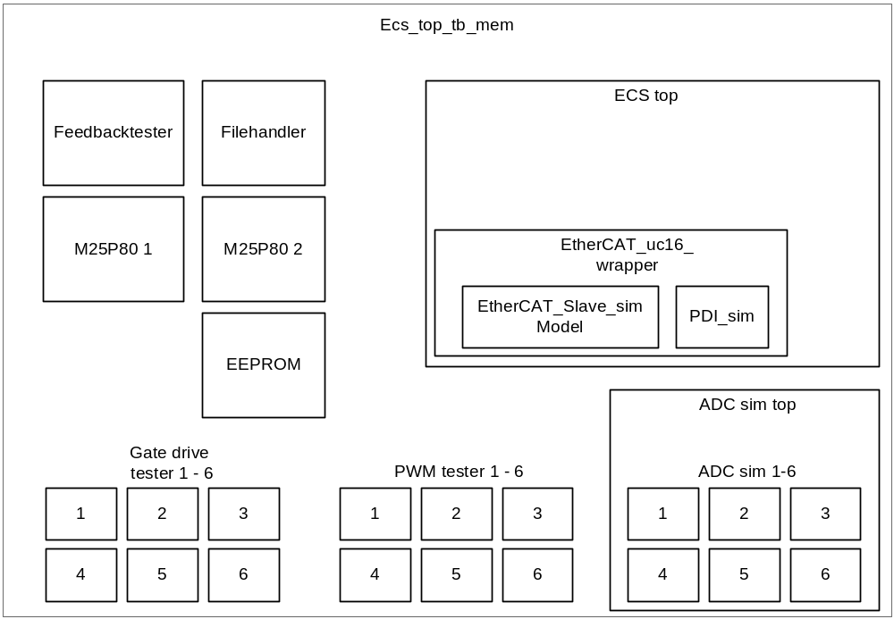
Figure 1. Block diagram over test bench blocks

Ecs top tb mem
This is the top hierarchy of the testbench where the design is connected with testbench blocks. Probed signals from within the design are connected here with the signal spy command.
The block holds the following functions:
- A couple of tests are performed at top level, see test description chapter.
- Reset and clock is generated from this block.
- “SELECTEDFLASH” selects to which flash memory chip select shall be connected to.
- Generating the “phasetrig” pulses to emulate that the mains contactor is engaged.

Filehandler
The filehandler block reads the “ECSA.txt” stimuli file. See Process stimuli file4.1. One row at a time is read when signal “fileReadTrigg” is active. This signal is derived mainly from when “pu_trigg” is set every 63 us tick. Each new row in “ECSA.txt” is read into a struct which is used by “feedbacktester” and “pwmtester” block.
The signal “startCheck” is set after tick 6. This signal tells “feedbacktester” to start checking the output after the boost up sequence is done.

M25P80
This block is a simulation model provided by the chip vendor for the flash memory. The memory stores the FPGA firmware. There are two instances of the memory. At simulation only memory two is written to and read from.

Eeprom
This block is a simulation model of the Eeprom used. The code base is taken from the M25P80 simulation model.

Feedback tester
This block checks feedback data. Feedback data is compared either to reference data from “ECSA.txt” or from internal signals in the design. To probe internal signals the “signal spy” command is used. This is a Modelsim specific command. The signal spy commands are done at top level in “ecs_top_tb_mem”.
The tester is only active when “SEND_PROCESS_DATA” test is run from “ethercat_slave_sim”. The tester stops when “adc_sim_done” is set which indicates that no more ADC simulation data is available.
It is only the error conditions that are reported. When test is finished, the number of errors detected is reported. Error texts are stored in “transcript.log” and “error.log”.
Feedback data is read directly from the databus to ECS. The comparison is made in a single process that starts for the first time when the boost up sequence is done. One data word at a time is compared and then it waits for next data to be valid for reading. Data is valid when “pdiBusy” is active low and a valid address is available.
Feedback tester will be temporarily stopped when;
“inv_fdbck_chk_en” is reset which occurs when “resetInverterFailure” is forced high.
“pwmActive” is reset.
“isRefDataError” is set because testbench is running com failure tests

ADC sim
“Adc_sim_top” block reads data from a text stimuli file and copies data to six instances of the “Adc_sim” block. “Adc_sim” is a simulation model of the ADC’s used for the design. It takes 4 channels of 16 bit AD data and sends it through SPI to “ecs_top”.
The stimuli file is called “adc_stimuli_toplevel_tc1.txt”. One row of the file corresponds to one 63 us tick. Each column in the file represents one AD channel. New values are read when “fileReadTrigg” is set.
When end of file is reached “adc_sim_done” is set and the feedback data error counter is written to transcript window.
The ADC stimulus is only read during “SEND_PROCESS_DATA” test.

Gate drive tester
This block tests for each node:
- Boost up sequence
- Inverter short circuit
- Clearing of inverter short circuit
- Inverter over temperature
- Inverter failure

The block manipulates the gate drive trip signal “dr_trip_n”
For more info regarding the function see corresponding tests.
If any errors are found they will be written to “transcript.log” and “error.log”.

PWM tester
PWM tester checks the PWM switch on times for a single node. The time from the PWM centre point to the switching point is measured and then checked towards a reference value found in the struct "driveUnitRefData". The struct data comes from “ECSA.txt”.
This tester allows a difference between a measured time and the calculated reference time of maximum 50 ns, otherwise an error message will be printed. 50 ns is the current FPGA delay for generating the PWM compared to an ideal PWM pulse.
The tester is split into three processes, one for each motor phase.
The tester only runs during “SEND_PROCESS_DATA” test and it will be paused if “pwmActive” is cleared.
If any errors are found they will be written to “transcript.log” and “error.log”.

Ethercat uc16 wrapper
This block instantiates the “ethercat slave sim” and “pdi sim” block. The wrapper connects the blocks together.

PDI sim
This block translates uc16 data to DPM signals. The read and write accesses are made through a state machine called “pdi_state”. The state machine waits in idle state until “wr_n” or “rd_n” strobe is active. It will then start the read or write transfer of data.

Ethercat slave sim
This block acts as a simulation model for the Ethercat slave IP block. It is not intended to be a 100 % exact model of the IP core, it is instead a stimuli generator which copies data to a memory array that the design reads out as if it was the real IP core. The block is dependent on “testcases.txt” file. This file is read in “read_test_cases” process when simulation is started up. Every test can be run as many times as desired. The array “test_case” stores every test that shall be run as a unique number. The array supports 64 tests to be run for the moment. The array is read by test stimuli process “file_tb”.
“file_tb” process generates test stimuli to the design, mainly “mailbox” and “ESM”. The process is clocked with 100 Mhz system clock. There is one large state machine holding all supported testcases. The states are decoded from the “test_case” array number in the “change_state” procedure which is called after each test is done. At startup “RESET” state is first entered. From here signals is initialized and the ECS RAM memory is cleared. The state machine proceeds to “GET_FIRST_TEST”. This state waits for the first interrupt and then it fetches the first test to be run.
Every test is dependent on the signal “timer_pulse” which works as an enable signal for new events. This signal is the PDI interrupt signal. It is generated in “timer_tb” process. The “timer_pulse” is active for one clock cycle. The cycle time is adjustable through the “timer_max” signal. There are two reasons for that. One is to generate interrupts with the exact tick interval written to the process data stimuli file “ECSA.txt” The other reason is to optimize simulation runtime. In every test case the interrupt time is adjusted depending on how long the test will take. The interrupt can be disabled by setting the “lost_frame” signal.
When it is desired to stay in one test for several interrupts a counter named “irq_cnt” is used to keep track on which irq tick the test is in for the moment. This counter is reset every time “change_state” is called.

Output check
The outcome from every test in “ethercat_slave_sim” is checked in the “check_output” process. The process is built around the same state machine as the input stimuli process. The state machine uses “timer_pulse” and wait statements to wait for the correct time to check the output.
When a test has passed, an info message is written to the transcript window. If a test fails an error message is written to the transcript window and the simulator is stopped.
State changes are checked in a separate process called “check_state”. It will send an info message to transcript window each time when AL status register is written reporting which the current state is. If a state change error occurred the simulator will stop and an error message will be written.

tbDefinitions
This is a library file used by the testbench blocks. Shared structs and procedures are declared in this block.
Supported procedures:
- print
  - Prints a message from a specific tester
- checkTime
  - Compares two times, and prints error message
- checkData16, checkData3 and checkData
  - Compares two vectors/bits and prints error message
- put
  - Prints a linefeed to the report file
- put_l
  - Prints a line separator to the report file
- errorfound
  - increases error found counter
- printerrorcounter
  - Prints the number of encountered errors when the simulation has finalized

Testcases
This chapter lists all testcases available in the testbench.

Test 1 |  | power board supply
Name | power board supply |  | Block | Ecs_top_tb
Requirement |  | Power board supply error shall be detected if GATEVOLT_17VOK is low for more than 60 us.
Expected result |  | AX_DETACH_N and powerBoardSupplyFail shall be set on power boards supply error. When filter time threshold is excided.
Test setup |  | Set GATEVOLT_17VOK low for 30 us, then high for 50 us and then low for 70 us.

Test 2 |  | Control board power supply
Name | Control board power supply |  | Block | Ecs_top_tb
Requirement |  | Control board power supply error shall be detected if PWROK is low for more then 60 us.
Expected result |  | AX_DETACH_N shall be set when filter time threshold is excided.
Test setup |  | Set PWROK low for 50 us then high for 100 us and then low for 80 us.

Test 3 |  | Bleeder Short Circuit
Name | Bleeder Short Circuit |  | Block | Ecs_top_tb
Requirement |  | Bleeder short circuit shall be detected when bleederFltSD_n and GATEVOLT_17VOK is set for more than 60 us.
Expected result |  | bleederShortCircuit shall be set when condition is met and filter time threshold is excided.
Test setup |  | Set bleederFltSD_n and reset GATEVOLT_17VOK for 80 us  Set GATEVOLT_17VOK for 80 us  Set bleederFltSD_n for 40 us.  Reset bleederFltSD_n for 100 us.  Set bleederFltSD_n for 80 us.

Test 4 |  | Bleeder IGBT Short Circuit
Name | bld_test |  | Block | Ecs_top_tb
Requirement |  | Bleed IGBT short circuit shall be set after 3 consecutive ticks when bleeder voltage is lower than half of dc main voltage, inrush is not active and bleeder is off. Bleeder must have been off for more than 25 ms.
Expected result |  | bleederIGBTShortCircuit should be set when requirement is fulfilled.
Test setup |  | The bleeder off time that is used in the design is reduced to 3 ticks in simulation. This is done to reduce simulation time.  Generate bleeder voltage that is less than half the dc voltage for less time than needed to trigger short circuit detection.  Generate bleeder voltage that is less than half the dc voltage for longer time than needed to trigger short circuit detection.

Test 5 |  | Flash and eeprom memory test timing
Name | Flash and eeprom memory test 1 |  | Block | M25P80, eeprom
Requirement |  | All timing for the memories must be met according to memory datasheet.
Expected result |  | No error messages from simulation model should be generated.
Test setup |  | Use simulation model from memory vendor with built in self check regarding timing.

Test 6 |  | Flash and eeprom memory test communication
Name | Flash and eeprom memory test 2 |  | Block | M25P80, eeprom
Requirement |  | The commands sequences for all types of accesses must be met according to memory datasheet.
Expected result |  | No error messages from simulation model should be generated.
Test setup |  | Use simulation model from memory vendor with built in self check regarding command sequences.

Test 7 |  | Inverter Short Circuit
Name | Inverter Short Circuit |  | Block | Gatedrivertester
Requirement |  | The UUT shall be able to detect short circuit.
Expected result |  | gateDriveFltClr, inverterShortCircuit and inverterFailure shall be set when drTrip_n is set.
Test setup |  | Set drTrip_n active low. Wait up to 500 us for gateDriveFltClr do be set. If gateDriveFltClr is set, clear drTrip_n and wait for 50 us. Read inverterShortCircuit and inverterFailure, both shall be set. Clear fault with resetInverterFailure.

Test 8 |  | Inverter over temperature
Name | Inverter over temperature |  | Block | Gatedrivertester
Requirement |  | The UUT shall be able to detect over temperature
Expected result |  | gateDriveFltClr, inverterTempTooHigh and inverterFailure shall be set when drTrip_n is set and not cleared after gateDriveFltClr is set.
Test setup |  | Set drTrip_n active low. Wait up to 500 us for gateDriveFltClr do be set. If gateDriveFltClr is set, wait for 50 us. Read inverterTempTooHigh and inverterFailure, both shall be set. Clear fault with resetInverterFailure.

Test 9 |  | Boost sequence
Name | Checking boost sequence |  | Block | Gatedrivertester
Requirement |  | The UUT shall set faultClr during boost sequence
Expected result |  | faultClr shall be set when boostInProgress is set.
Test setup |  | Wait until boostInProgress is set. Check that faultClr is set. Wait until boostInProgress is reset. Check that faultClr is reset.

Test 10 |  | Feedback tester
Name | Feedback tester |  | Block | Feedbacktester
Requirement |  | Feedback data shall be generated correct.
Expected result |  | Feedback data shall equal stimuli data and internal signals in the design every tick. The tester checks both that stimuli propagate correct through the design and that the internally generated signals are correct mapped in the feedback register map.
Test setup |  | Feedback data shall be compared to reference data stimuli from “ECSA.txt” and ADC data stimuli from “adc_stimuli_toplevel_tc1.txt”. Register bits generated in the design is compared to corresponding signals in the design where they are generated.  Feedback tester waits until boost sequence is done before checker is started. The tester waits until new data is available on the PDI bus. An address comparison is made and the PDI data is compared with the expected result. The tester runs in an endless loop.  DC voltage can only be checked every other tick.

Test 11 |  | Feedback tester
Name | Feedback tester |  | Block | Feedbacktester
Requirement |  | isRefDataError shall be set on communication error. After MAX_LOST_FRAMES number of communication errors in a row CommFailure shall be set.
Expected result |  | isRefDataError shall be set when isReferenceData is cleared. CommFailure shall be set after 5 ticks of corrupt packets.
Test setup |  | Set MAX_LOST_FRAMES to 5. Clear isRefrenceData, Check that isRefDataError is set in feedback data. On the fifth tick CommFailure shall also be set.

Test 12 |  | Feedback tester
Name | Feedback tester |  | Block | Feedbacktester
Requirement |  | refSeqError shall be set when sequence numbering is incorrect. After MAX_LOST_FRAMES number of communication errors in a row CommFailure shall be set.
Expected result |  | refSeqError shall be set when seqno is not increased on every new frame. CommFailure shall be set after 5 ticks of corrupt packets.
Test setup |  | Set MAX_LOST_FRAMES to 5. Stop increasing seqno, Check that refSeqError is set in feedback data. On the fifth tick CommFailure shall also be set.

Test 13 |  | Feedback tester
Name | Feedback tester |  | Block | Feedbacktester
Requirement |  | refTimeOut shall be set when no reference data frame is sent within WATCHDOG_TIMEOUT_INTERVAL+WATCHDOG_TIMEOUT. After MAX_LOST_FRAMES number of communication errors in a row CommFailure shall be set.
Expected result |  | refTimeOut shell be set when the time between to frames is more than 73 us (63us +10us). CommFailure shall be set after 5 ticks of corrupt packets.
Test setup |  | Set MAX_LOST_FRAMES to 5. Set WATCHDOG_TIMEOUT_INTERVAL to 63. Set WATCHDOG_TIMEOUT to 10. Stop sending process data to slave. Check that refTimeOut is set in feedback data. On the fifth tick CommFailure shall also be set.

Test 14 |  | PWM test
Name | PWM tester phase U, V and W |  | Block | PWMtester
Requirement |  | Switch on times shall follow PWM on times sent in reference frames. Max deviation from theoretical value shall be 50 ns.
Expected result |  | The time from the PWM centre point to the switching point shall equal the reference turn on time.
Test setup |  | Each node and phase is checked separately. Start tester when PWM is active. Wait until “pwsync” is set which indicates the centre point of the PWM. Store the simulator time as tStart. Store the turn on time as tRefInt.  For PWM top leg:  tRef := (12600 - tRefInt) * 10 ns;  Wait until PWM top is set to ‘0’.  Compare: tRef = now – tStart  If they differs more than 50 ns then it is not ok.  For PWM bottom leg:  tRef := tRefInt * 10 ns;  Wait until PWM bottom is set to ‘0’.  Compare: tRef = now – tStart  If they differs more than 50 ns then it is not ok.  For invalid frames:  Use previous reference values and do comparison above.

Test 15, 16 |  | Read firmware information.
Name | COE_FIRMWARE_INFO_UPLOAD  FOE_FIRMWARE_INFO_UPLOAD |  | Block | EtherCAT_Slave_simModel
Requirement |  | Registers shall be readable with CANopen and FoE.
Expected result |  | MIN_PWM_DELAY_TIME = $04B0  MAX_PWM_DELAY_TIME = $1194  PROCESS_DATA_OUTPUT_LENGTH = $0028  PROCESS_DATA_INPUT_LENGTH = $0028
Test setup |  | COE:  Mailbox write event. Coe access with SDO request and firmware info object specified. Read data from ram.  FOE:  Mailbox write event. Foe access with read request and firmware info file specified. Mailbox write event. Foe access with acknowledge request. Read data from ram.

Test 17, 18 |  | Write application configuration data
Name | COE_APP_CONF_DOWNLOAD  FOE_APP_CONF_DOWNLOAD |  | Block | EtherCAT_Slave_simModel
Requirement |  | Registers in slave controller shall be programmed correctly.
Expected result |  | Maxnooflostframes =X"5"  mduProtocolVersion=X"01"  bleederTurnOnLevel=X"0EA0"  bleederTurnOffLevel=X"0E40"  bleederTestLevel =X"09A8"  dcSettleLevel =X"000F"  dcEngageLevel =X"08E8"  dcDisengageLevel =X"087E"  mainsVACType =X"1"  deadTimeInverter1=X"0078"  deadTimeInverter2= X"0082"  deadTimeInverter3= X"008C"  deadTimeInverter4= X"0096"  deadTimeInverter5= X"0078"  deadTimeInverter6 =X"0078"  wdtTimeout =X"0064"  wdtTimeoutInterval=X"189C"
Test setup |  | COE:  Mailbox write event. Coe access with SDO download request and application configuration object specified. Write data to ram.  FOE:  Mailbox write event. Foe access with write request and application configuration file specified. Mailbox write event. Foe access with data request. Write data to ram

Test 19 |  | Invalid packet length field
Name | INVALID_LENGTH |  | Block | EtherCAT_Slave_simModel
Requirement |  | Mailbox shall detect when MBpacket length field is set to a higher value than max buffer size which is set to $130.
Expected result |  | MBheader length shall be set to 0 on ack from mailbox.
Test setup

Test 20 |  | Communication failure and restart test
Name | COM_FAIL_RESTART |  | Block | EtherCAT_Slave_simModel
Requirement |  | When going from bootstrap state to init state a system reset shall be generated.
Expected result |  | A reset pulse shall be detected.
Test setup

Test 21 |  | Write firmware to memory
Name | WRITE_FIRMWARE |  | Block | EtherCAT_Slave_simModel
Requirement |  | It shall be possible to write firmware to flash memory.
Expected result |  | See test 22.
Test setup

Test 22 |  | Read firmware from memory
Name | READ_FIRMWARE |  | Block | EtherCAT_Slave_simModel
Requirement |  | It shall be possible read the firmware from flash memory.
Expected result |  | Written data shall be equal to read data.
Test setup

Test 23 |  | Write firmware valid flag to memory.
Name | WRITE_FW_VALID_FLAG |  | Block | EtherCAT_Slave_simModel
Requirement |  | It shall be possible to write the firmware valid flag to flash memory.
Expected result |  | See test 24.
Test setup

Test 24 |  | Read firmware valid flag from memory.
Name | READ_FW_VALID_FLAG |  | Block | EtherCAT_Slave_simModel
Requirement |  | It shall be possible to read the firmware valid flag from flash memory.
Expected result |  | Read value should be $00BC.
Test setup

Test 25, 26 |  | Write to hardware info and calibration memory area.
Name | WRITE_PB_HW_INFORMATION / WRITE_PB_CALIB_DATA |  | Block | EtherCAT_Slave_simModel
Requirement |  | It shall be possible to write to hardware info and calibration memory area.
Expected result |  | See test 27 and 28.
Test setup

Test 27, 28 |  | Read from hardware info and calibration memory area.
Name | READ_PB_HW_INFORMATION / READ_PB_CALIB_DATA |  | Block | EtherCAT_Slave_simModel
Requirement |  | It shall be possible to read from hardware info and calibration memory area.
Expected result |  | Memory content shall equal to written data in test 25 and 26.
Test setup

Test 29 |  | FoE access with incorrect filename set.
Name | INCORRECT_FILENAME |  | Block | EtherCAT_Slave_simModel
Requirement |  | It shall not be possible to write data with an unknown filename.
Expected result |  | Error request op code $0005 and error code $8001.
Test setup

Test 30 |  | FoE write access on readonly register.
Name | FOE_WRITE_ON_READ |  | Block | EtherCAT_Slave_simModel
Requirement |  | It shall not be possible to write data to a read only register.
Expected result |  | Error request op code $0005 and error code $8002.
Test setup

Test 31 |  | FoE read access on write only register.
Name | FOE_READ_ON_WRITEONLY |  | Block | EtherCAT_Slave_simModel
Requirement |  | It shall not be possible to read data from a write only register. Try to read from application config register.
Expected result |  | Error request op code $0005 and error code $8002. Read request should be aborted. Mailbox should read last position in buffer immediately.
Test setup

Test 32 |  | CoE write access on readonly register.
Name | COE_WRITE_ON_READ |  | Block | EtherCAT_Slave_simModel
Requirement |  | It shall not be possible to write data to a read only register. Try to write to firmware info register.
Expected result |  | Abort transfer req $4, abort code $00010504 and firmware info object code $4001.
Test setup

Test 33 |  | CoE read access on write only register.
Name | COE_READ_ON_WRITEONLY |  | Block | EtherCAT_Slave_simModel
Requirement |  | It shall not be possible to read data from a write only register. Try to read from application config register.
Expected result |  | Abort transfer req $4, abort code $00010504 and application config object code $4002.
Test setup

Test 34 |  | CoE access with incorrect command specifier
Name | COE_INCOR_CMD_SPECIFIER |  | Block | EtherCAT_Slave_simModel
Requirement |  | It shall not be possible to do an incorrect command specifier access. Do the access to firmware info register.
Expected result |  | Abort transfer req $4, abort code $00010504 and firmware info object code $4001.
Test setup

Test 35 |  | CoE access with incorrect service field
Name | COE_INCORRECT_SERVICE |  | Block | EtherCAT_Slave_simModel
Requirement |  | It shall not be possible to do an incorrect service access. Do the access to application config register.
Expected result |  | Abort transfer req $4, abort code $00000601 and application config object code $4002.
Test setup

Test 36 |  | FoE access with incorrect opcode
Name | INCORRECT_OPCODE |  | Block | EtherCAT_Slave_simModel
Requirement |  | It shall not be possible to do an access with incorrect opcode.
Expected result |  | Error code $8000.
Test setup

Test 37 |  | FoE access with incorrect mailbox protocol type
Name | INCORRECT_MBOX_PROT_TYPE |  | Block | EtherCAT_Slave_simModel
Requirement |  | It shall not be possible to do an access with incorrect mailbox protocol type.
Expected result |  | Error code $00.
Test setup

Test 38 |  | FoE packet sequence number
Name | PACKET_NO |  | Block | EtherCAT_Slave_simModel
Requirement |  | Each packet should have a packet sequence number.
Expected result |  | Check that the sequence number is increased after each packet.
Test setup

Test 39 |  | Invalid FoE request sequence
Name | INVALID_FOE_REQ_SEQ |  | Block | EtherCAT_Slave_simModel
Requirement |  | An error code shall be generated after an invalid request sequence.
Expected result |  | Error code $8004.
Test setup

Test 40 |  | Invalid FoE request sequence
Name | INVALID_FOE_REQ_SEQ_1 |  | Block | EtherCAT_Slave_simModel
Requirement |  | An error code shall be generated after an invalid request sequence.
Expected result |  | Error code $8004.
Test setup

Test 41 |  | Error request
Name | ERROR_REQUEST |  | Block | EtherCAT_Slave_simModel
Requirement |  | When an error request is sent, mailbox shall answer with sending the last read packet again.
Expected result |  | Read data shall equal last read data.
Test setup

Test 42 |  | CoE invalid object number
Name | COE_INVALID_OBJECT |  | Block | EtherCAT_Slave_simModel
Requirement |  | Doing an access with invalid object number shall result in an abort transfer request.
Expected result |  | Abort transfer req $4, abort code $00000602 and application config object code $4003.
Test setup

Test 43 |  | FoE invalid length
Name | INVALID_LENGTH |  | Block | EtherCAT_Slave_simModel
Requirement |  | A packet with larger buffer size than 262 shall be rejected.
Expected result |  | Length field shall be set to 0 by mailbox.
Test setup

Test 44 |  | Send process data
Name | SEND_PROCESS_DATA |  | Block | EtherCAT_Slave_simModel
Requirement
Expected result |  | Process data is read from a text file. Output is tested in feedback tester. Test is done when no more adc data is available or when the user variable “nr_of_periodics” equals the number of simulated periods.
Test setup

Test 45
Name | SETUP_SYNC_MAILBOX |  | Block | EtherCAT_Slave_simModel
Requirement |  | It shall be possible to configure the sync manager mailbox registers.
Expected result |  | Tested through other testcases.
Test setup

Test 46
Name | SETUP_SYNC_PROCESS |  | Block | EtherCAT_Slave_simModel
Requirement |  | It shall be possible to configure the sync manager process input and output registers.
Expected result |  | Tested through other testcases.
Test setup

Test 47 |  | Check the transition to init state.
Name | TO_INIT_STATE, STATE_TRANSITIONS |  | Block | EtherCAT_Slave_simModel
Requirement |  | It shall be possible to enter init state from bootstrap, safe-operational, pre-operational and operational.
Expected result |  | AL status register shall be set to $1.
Test setup

Test 48 |  | Check the transition to pre-operational state.
Name | TO_PRE_OP_STATE, STATE_TRANSITIONS |  | Block | EtherCAT_Slave_simModel
Requirement |  | It shall be possible to enter pre-operational state from init, safe-operational and operational.
Expected result |  | AL status register shall be set to $2.
Test setup

Test 49 |  | Check the transition to safe operational state.
Name | TO_SAFE_OP_STATE, STATE_TRANSITIONS |  | Block | EtherCAT_Slave_simModel
Requirement |  | It shall be possible to enter safe operational state from operational and pre-operational.
Expected result |  | AL status register shall be set to $4.
Test setup

Test 50 |  | Check the transition to operational state.
Name | TO_OP_STATE, STATE_TRANSITIONS |  | Block | EtherCAT_Slave_simModel
Requirement |  | It shall be possible to enter init state from bootstrap, safe-operational, pre-operational and operational.
Expected result |  | AL status register shall be set to $8.
Test setup

Test 51 |  | Check the transition to bootstrap state.
Name | TO_BOOTSTRAP_STATE, STATE_TRANSITIONS |  | Block | EtherCAT_Slave_simModel
Requirement |  | It shall be possible to enter bootstrap state only from init.
Expected result |  | AL status register shall be set to $3.
Test setup

Test 52 |  | Going to an unknown state.
Name | TO_UNKNOWN_STATE |  | Block | EtherCAT_Slave_simModel
Requirement |  | It shall not be possible to enter any other state than 1, 2, 3, 4, and 8. Error code shall not be cleared without master sending a clear request.
Expected result |  | AL status register shall be set to $001X. AL status code register shall be $0012.
Test setup

Test 53 |  | Check the transition to safe operational state when the sync manager is not setup correct.
Name | UNVALID_TO_SAFE_OP_STATE |  | Block | EtherCAT_Slave_simModel
Requirement |  | It shall not be possible to enter safe operational state when the process sync manager in not set correct.
Expected result |  | AL status code register shall be set to $17.
Test setup

Test 54 |  | Check all possible state transitions.
Name | STATE_TRANSITIONS |  | Block | EtherCAT_Slave_simModel
Requirement |  | It shall only be possible to enter states as described in EtherCat specification.
Expected result |  | AL status register shall be set to new state. On faulty state changes AL status register shall be set to $001X and AL status code register shall be set to $0011. When master has cleared error, AL status code register shall be 0.
Test setup

Test 55 |  | Check the transition to preoperational state when mailbox sync manager is not configured.
Name | TO_PREOP_NO_MBX_SM |  | Block | EtherCAT_Slave_simModel
Requirement |  | It shall not be possible to enter preoperational state when the mailbox sync manger is not configured.
Expected result |  | AL status code register shall be set to $0016.
Test setup

Test 56 |  | Check the transition to bootstrap state when mailbox sync manager is not configured.
Name | TO_BOOTSTR_NO_MBX_SM |  | Block | EtherCAT_Slave_simModel
Requirement |  | It shall not be possible to enter bootstrap state when the mailbox sync manger is not configured.
Expected result |  | AL status code register shall be set to $0015.
Test setup

Test 57 |  | Check the transition to safe operational state when the sync manager is not setup correct.
Name | TO_SAFEOP_NO_PRC_SM |  | Block | EtherCAT_Slave_simModel
Requirement |  | It shall not be possible to enter safe operational state when the process sync manager in not set correct.
Expected result |  | AL status code register shall be set to $17.
Test setup

Test 58 |  | Check the transition to operational state when the sync manager is not setup correct. Check error condition when sync manager reg is cleared in pre operational state. Changing state when mailbox sync manager is not set correct.
Name | TO_PROCESS_NO_PRC_SM |  | Block | EtherCAT_Slave_simModel
Requirement |  | It shall not be possible to enter operational state when the process sync manager in not set correct. Error code shall be generated when trying to change to pre operational state from pre operational state without a correct sync manager setup.  When not in init state, it shall not be possible to change state when mailbox sync manager is not set correct.
Expected result |  | AL status code register shall be set to $0017 for the first two tests and set to $0016 for the last test.
Test setup

Test 59 |  | Check the transition to operational state without correct process sync manager.
Name | NO_PROCESS_SM_MATCH |  | Block | EtherCAT_Slave_simModel
Requirement |  | An error code shall be generated when trying to change state from operational to operational without correct process output sync manager.
Expected result |  | AL status code register shall be set to $0017.
Test setup

Test 60 |  | Check the transition to operational state without correct process sync manager.
Name | TO_OP_NO_CFG_DONE |  | Block | EtherCAT_Slave_simModel
Requirement |  | An error code shall be generated when trying to change state from safeoperational to operational without correct process output sync manager.
Expected result |  | AL status code register shall be set to $0001.
Test setup

Test 61 |  | Boot FPGA from Flash 1
Name | USE_FPGA_DEF_FIRMWARE |  | Block | EtherCAT_Slave_simModel
Requirement |  | When valid flag is not set, FPGA shall use flash 1 only during boot up.
Expected result |  | “Selectedflash” shall be ‘0’ when 0xBC is not written to flash 2.
Test setup |  | Enter valid code(0xBC) to flash 2. Start up. Check “selectedflash” after 1 ms. It should be set to ‘1’. Remove valid code. Start up again. Check “selectedflash” after 340 us. It should be set to ‘0’.

Test 62, 63 |  | Read application configuration data
Name | FOE_APP_CONF_UPLOAD/ COE_APP_CONF_UPLOAD |  | Block | EtherCAT_Slave_simModel
Requirement |  | It shall be possible to read back the written application configuration data
Expected result |  | Data shall be equal to written data. See test 17 and 18.
Test setup

Test 64, 65 |  | Write to PB eeprom
Name | WRITE_PB_EEPROM_1 /  WRITE_PB_EEPROM_2 |  | Block | EtherCAT_Slave_simModel
Requirement |  | It shall be possible to write 256 bytes of data to PB eeprom 1 and 2.
Expected result |  | See test 66 and 67.
Test setup |  | Write data starting at the lowest address with data 0. Increase data by one for every new address. Every write access shall transfer 32 bytes of data. Write data the opposite way to eeprom 2, starting at 255 and counting down.  Defined filename is 7 and 8 to access eeprom.

Test 66, 67 |  | Read from PB eeprom
Name | READ_PB_EEPROM_1 /  READ_PB_EEPROM_2 |  | Block | EtherCAT_Slave_simModel
Requirement |  | It shall be possible to read 256 bytes of data from PB eeprom 1 and 2.
Expected result |  | Data shall be equal to the written data in test 64 and 65.
Test setup |  | Read and compare data. All data is read in one packet.

Test 68
Name |  |  | Block
Requirement
Expected result
Test setup

Stimuli files

Process stimuli file
Process data is read from a text file “ECSA.txt” in the “sim” catalog. This file is generated from an Excel file called “DataSource_New_Robocat_v1.xls”. The file corresponds to the Ethercat protocol. Each row in the file corresponds to one 63 us tick.

Text file generator
Inside the Excel application is a model that describes the connection between the input parameters of the Excel application and the values in the output text file. This model is used to generate a file that contains the expected values of the output text file.
A snippet from the Excel application is shown in Figure 2. Snippet of the Excel ApplicationAll white cells are parameters. The colored cells contain values generated during execution of the application.
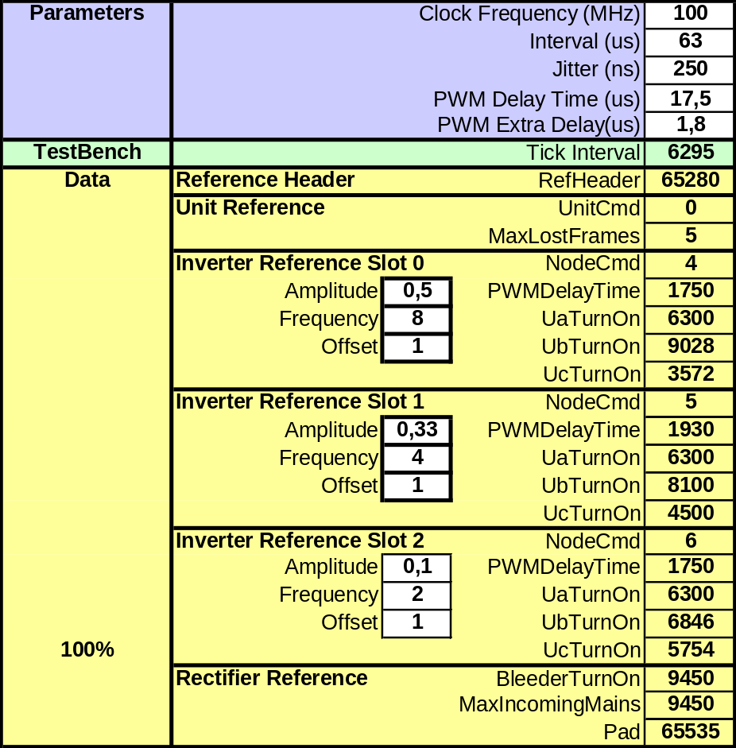
Figure 2. Snippet of the Excel Application

Parameters
The parameters used in the Excel Application are described in this section. The parameters can be seen in the following figures. There are three categories of parameters. They are defined as:
Sys : A system parameter describes some feature of the ECS Application. This implies that these parameter values must correspond to the hardcoded values in the ECS Application.
Ref : A reference parameter will be used to define the data in the reference areas of the output process data.
Mod : A modifying parameter is used to modify some data in the input text file.

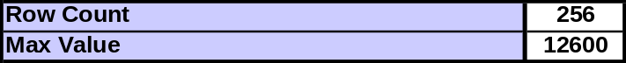
Figure 3. Global parameters

Row Count (Mod): Number of rows in the input/output text files (number of ticks).
Max Value (Sys): Max value for the TurnOnTimes.

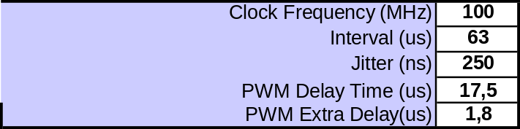
Figure 4. Parameters

Clock Frequency (MHz) (Sys): The clock frequency used by the UUT.
Interval (us) (Sys): The time interval in microseconds between two frames.
Jitter (ns) (Mod): The maximum jitter between two consecutive frames.
PWM Delay Time(us) (Ref): PWMDelayTime as defined in [2].
PWM Extra Delay(us) (Ref): The communication delay between two SMBs.

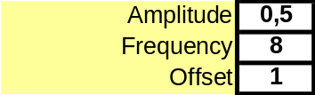
Figure 5. Parameters

Amplitude (Ref): Amplitude of the sinus curve used to generate the TurnOnTimes.
Frequency (Ref): Frequency of the sinus curve used to generate the TurnOnTimes.
Offset (Ref): Vertical offset from zero of the sinus curve used to generate the TurnOnTimes

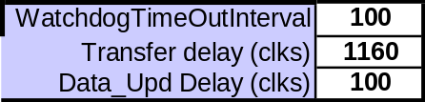
Figure 6. Parameters

WatchDogTimeOutInterval (Sys): The supervision watchdog timeout interval offset.
Transfer delay (clks) (Sys): Number of clks between event_trigg (delayed pdi_irq) and data_updated.
Data Upd Delay (clks) (Sys?): ?

Tick
1
isReferenceData
0
ClearCommError
0
Figure 7. Parameters

Tick (Mod): The tick that the values in the same column are valid for.
isReferenceData (Ref): Defined in RoboCat protocol.
ClearCommError (Ref): Defined in RoboCat protocol.

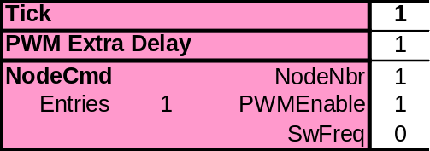
Figure 8. Parameters

Tick (Mod): The tick that the values in the same column are valid for
PWM Extra Delay (Mod): The pu_trigg signals will be generated with PWM Extra Delay(us) us delay
NodeNbr (Ref): Defined in RoboCat protocol.
PWMEnable (Ref): Defined in RoboCat protocol.
SWFreq (Ref): Defined in RoboCat protocol.

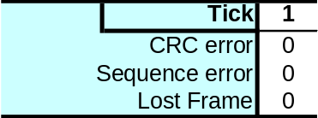
Figure 9. Parameters

Tick (Mod): The tick that the values in the same column are valid for.
CRC error (Mod): The process data will contain crc error.
Sequence error (Mod): The process data will contain sequence error.
Lost frame (Mod): No pdi_irq will be generated (simulates a lost frame).

Erroneous frames
The parameters seen in Figure 9. Parameters are used to generate frames that contain errors. This can be used to simulate that the UUT can handle loss of frames or frames containing CRC or Sequence number errors. The different error condition modifies certain data in the input text file. The Excel application has a model that modifies certain data in the expected output text file.

Lost frames
Lost frames are indicated in the input text file by setting “tick_interval” to zero. This is detected by the EtherCAT slave simulator, which does not generate an “event_irq” for this frame. Since no “data_updated” signal is generated during erroneous frames, the PU_trigg_delay_x will equal the time between the “pdi_irq” signal and the “PU_trigg” signal for node x.

Sequence number error
The RefSeq byte in the process data from the input text file will be equal to the sequence number value of the previous frame during a Sequence number error condition. Since no “data_updated” signal is generated during erroneous frames, the PU_trigg_delay_x will equal the time between the “pdi_irq” signal and the “PU_trigg” signal for node x.

Communication failure
Since no “data_updated” and “PU_trigg” signals are generated during communication failure, the PU_trigg_delay_x will equal 0.

ADC stimuli file
“adc_stimuli_toplevel_tc1.txt” text file contains ADC data used during the simulation. Each row represents one tick. Each column contains one AD channel with 16 bit data. There are 22 channels in total. Below are AD channels listed from left to right.
uCurrent1, vCurrent1,
uCurrent2, vCurrent2,
uCurrent3, vCurrent3,
uCurrent4, vCurrent4,
uCurrent5, vCurrent5,
uCurrent6, vCurrent6,
igbtTemp1, igbtTemp2, igbtTemp3, igbtTemp4, igbtTemp5, igbtTemp6,
rectTemp,
dc_v,
re1_v, re2_v

Running the testbench
The design has been simulated with Mentor Graphics ModelSim 6.5c. Before any attempt is made to run the simulation make sure that Xilinx specific simulation libraries, unisim and Xilinxcorelib is compiled. Xilinx ISE version 9.x and later can be used to compile these libraries.
After starting Modelsim, change working directory to <proj_dir>\simulation\sim.
Compiling and running the design is made from a script file called “setup_sim.do” Invoke the script by typing “do setup_sim.do” in the transcript window. Compile the design by typing “com_all” and run the simulation by typing “run_tb”. The simulation will now start and all testcases will run. The simulation will stop after ~45 ms and a waveform window is opened with some signals added.
To reduce simulation time testcases can be removed by opening “testcases.txt” and type a ‘#’ before tests that should not run. Note that some tests are necessary to run the design.
The testbench will stop if error conditions are detected from mailbox test cases. An explaining text will be written to transcript window. Info messages is written to transcript window during simulation, they works as an acknowledge that a test has passed.
Note that the simulator will not stop for errors if the “Immediate assertion break severity” switch in Modelsim will be set to “Fatal”.
Everything written to the transcript window will be saved in the “transcript.log” text file.
Errors found during “SEND_PROCESS_DATA” test will not stop the simulator. They will only be written to transcript window and to “error.log” file.

REVISION
Rev.  ind. | Page (P)  Chapt.(C) | Description | Date  Dept./Init.
0.1 |  | Initial release, Lucas Lodesten | 091029

